INTERSTATE TRAVEL PASSPORT

SYSTEM

NURUL AMIRA BINTI ANWAR

SESSION 2020/2021

FACULTY OF COMPUTING AND INFORMATICS

MULTIMEDIA UNIVERSITY

JUNE 2021

INTERSTATE TRAVEL PASSPORT

SYSTEM

BY

NURUL AMIRA BINTI ANWAR

SESSION

2020/2021

THIS PROJECT REPORT IS

PREPARED FOR

FACULTY OF COMPUTING AND INFORMATICS

MULTIMEDIA UNIVERSITY

IN PARTIAL FULFILLMENT

FOR

BACHELOR OF INFORMATION TECHNOLOGY

B.IT (HONS) INFORMATION SYSTEMS

FACULTY OF COMPUTING AND INFORMATICS

MULTIMEDIA UNIVERSITY

JUNE 2021

Copyright of this report belongs to Universiti Telekom Sdn. Bhd. as qualified by Regulation 7.2 (c) of the Multimedia University Intellectual Property and Commercialisation Policy. No part of this publication may be reproduced, stored in or introduced into a retrieval system, or transmitted in any form or by any means (electronic, mechanical, photocopying, recording, or otherwise), or for any purpose, without the express written permission of Universiti Telekom Sdn. Bhd. Due acknowledgement shall always be made of the use of any material contained in, or derived from, this report.

© 2020 Universiti Telekom Sdn. Bhd. ALL RIGHTS RESERVED.

DECLARATION

I hereby declare that the work has been done by myself and no portion of the work contained in this thesis has been submitted in support of any application for any other degree or qualification of this or any other university or institute of learning.

_______________________

NURUL AMIRA BINTI ANWAR

Faculty of Computing & Informatics

Multimedia University

Date: 24/11/2021

# ACKNOWLEDGEMENT

First and foremost, all praise is due to the Almighty Allah S.W.T for His blessings and for providing me with the strength to successfully complete this final year project. I would like to express my heartfelt appreciation to my supervisor, Dr. Wan Noorshahida for her continuous guidance and comments in every part of this project. Dr. Shahida gave a lot of suggestion and tips for proper way to present a better report. Apart from that, she is also a kind and understanding supervisor when I had a problem.

Finally, I am grateful to my family and friends for their unwavering support and prayers. Without their support, I would not be able to finish this project. During this hard time, their encouragement is much needed and it was a relief when they care for me. Thank you.

# ABSTRACT

The rapidly increasing positive Covid 19 cases are quite worrying and as an initiative, the government has announced the partial lockdown which include the prohibition of interstate travel. However, there are several individuals who are permitted to cross the state with the requirement that they receive approval from the police station with valid reasons. As for now, the applicants need to go to the police station to get the permit form and fill in the details along with the supporting documents. This lead to result a long queue and the applicants had to waste their time as well as exposed to the virus for a long time. Interstate Travel Passport System is developed so the applicants can request the permit online. After the administrator officer check and approved, they will generate a QR Code and the status for the applicant will change from “PENDING” to “APPROVED”. With this system, it can also avoid fraud at the roadblock location because the applicants still need to go to the police station to get the QR code and change of status. This system will ease the applicants and the enforcement officer by clearing the traffics because the officer just need to scan the QR code to view the applicants status and details.  An online application is preferable to a manual one with the ever-improving smartphone. The main goal of this project was to develop a system that would allow users to have an easier process in a contactless way.

# Table of Contents

ACKNOWLEDGEMENT

ABSTRACT

Chapter 1 : INTRODUCTION 1

1.1 Problem Statement 1

Project Objectives 3

Project Scope 4

Report Organization 6

Chapter 2 : BACKGROUND STUDY 7

2.1 Existing Systems 7

2.1.1 Manual 7

2.1.2 Bantuan Prihatin Rakyat 9

2.1.2 MySejahtera 11

2.1.2 MMU Mobile 14

2.1.2 Gerak Malaysia 16

2.2 Comparison 17

Chapter 3 : REQUIREMENTS 19

System Overview 19

System Requirement 20

3.2.1 Software 20

3.2.2 Hardware 21

Functional Requirement 22

3.3.1 Use Case Diagram 22

3.3.2 Software Requirement Specifications (SRS) 23

3.3.3 Context Diagram 32

3.3.4 Data Flow Diagram 33

3.4 Non Functional Requirement 36

Chapter 4 : DESIGN 37

4.1 Sequence Diagrams 37

4.1.1 Permit Applicants 37

4.1.2 Roadblock Officer 38

4.1.3 Administrator Officer 39

4.2 Prototype 40

4.2.1 Mobile-based Application for Permit Applicants 40

4.2.2 Mobile-based Application for Roadblock Officer 43

4.2.3 Web-based Application for Administrator Officer 46

Chapter 5 : Implementation Plan 49

5.1 FYP 1 49

5.2 FYP 2 49

Chapter 6 : Conclusion 50

6.1 Conclusion 50

6.2 Obstacles 51

6.3 Future work 51

References 52

Appendix A : FYP 1 Meeting Logs 53

APPENDIX B : Turnitin Report 54

# List Of Tables

Table 2.1 Comparison between existing applications ………………………………………. 30

Table 3.1 Use Case 1 ……………………………………………………………………...… 35

Table 3.2 Use Case 2 ……………………………………………………………………...… 36

Table 3.3 Use Case 3 ………………………………………………………………………... 37

Table 3.4 Use Case 4 ………………………………………………………………………... 38

Table 3.5 Use Case 5 ………………………………………………………………………... 39

Table 3.6 Use Case 6 ………………………………………………………………………... 40

Table 3.7 Use Case 7 ………………………………………………………………………... 41

Table 3.8 Use Case 8 …………………………………………………………………...…… 42

Table 3.9 Use Case 9 ………………………………………………………………………... 43

Table 5.1 Gantt Chart FYP 1 ……………………………………………………………….. 61

Table 5.2 Gantt Chart FYP 2 ……………………………………………………………..… 61

# List Of Figures

Figure 2.1 Interstate Travel Permit Form ……………………………………………...……. 19

Figure 2.2 Bantuan Prihatin Rakyat …………………………………………………...……. 21

Figure 2.3 MySejahtera ………………………………………………………………...…… 23

Figure 2.4 MMU Mobile ……………………………………………………………...…….. 26

Figure 2.5 Gerak Malaysia ………………………………………………………………….. 28

Figure 3.1 System Overview ………………………………………...……………………… 31

Figure 3.2 Use Case Diagram ………………………………………………………………. 34

Figure 3.3 Context Diagram ………………………………………...………………………. 44

Figure 3.4 DFD Permit Applicants ………………………………………...……………….. 45

Figure 3.5 DFD Enforcement Officer …………………………………………...………….. 46

Figure 3.6 DFD Document Administrator ………………………………………………….. 47

Figure 4.1 Sequence Diagram Permit Applicant …………………………………………… 49

Figure 4.2 Sequence Diagram Enforcement Officer ……………………………..…………. 50

Figure 4.3 Sequence Diagram Document Officer ……………………………...…………… 51

Figure 4.4 Splash Screen and Login ……………………………………………………...… 52

Figure 4.5 Profile and Sign Up ……………………………...……………………………… 52

Figure 4.6 Dashboard and Profile …………………………………………………….…….. 53

Figure 4.7 Permit ……………………………………………………………………………. 54

Figure 4.8 Status for APPROVED and PENDING ………………………………..……….. 54

Figure 4.9 Sign In and Dashboard ………………………………………………………….. 55

Figure 4.10 Profile and Edit profile ………………………………….……..………………. 56

Figure 4.11 Approved and Rejected screen ………………………………………………… 56

Figure 4.12 Scan and Permit details ………………………………………………………… 57

Figure 4.13 Dashboard and Profile …………………………………………………….…… 58

Figure 4.14 Applicant List ………………………………………………………………….. 58

Figure 4.15 Review and Generate QR code ……………………………...…………………. 59

Figure 4.16 Rejected Reasons ……………………………………………………….……… 60

Figure 4.17 Statistics …………………………………………………………………..…60

# Chapter 1 : INTRODUCTION

1.1 Problem Statement

The government has announced the Movement Control Order (MCO) for 3 times which prohibits recreational and religious activities, closes all schools and universities, allows only essential services to operate and restricts interstate travel. The police along with soldiers are stationed at designated location to man roadblocks. They will check the travel permit and other documents and will only allow the person to continue their journey if the permit was signed and stamped from a police station. The process of crossing the state should be simple and uncomplicated with the mobile application for the applicants to apply for a permit.

Based on mysumber, on April 26th 2020, an application called "Gerak Malaysia" was developed by PDRM and MCMC with support by a telecommunication company. The application are primarily for individuals or families who have become stranded in the village and wish to return home. (mysumber, 2020)

However, according to NST, the application was discontinued on July 31st 2020 due to the uplift of the first MCO so the application was no longer required. The PDRM and MCMC also advised users to uninstall because it would be deactivated and all of their personal information would be sent to Health Ministry (NST, 2020)

Because the application only lasted a few months, once the second MCO was announced, the process for obtaining an interstate travel permit reverted to manual. The issue with using the permit manually is that some people abuse it by signing and stamping it without approval from the police station. There are also people who took the

clean, signed and stamped permit and printed a large number of copies to sell at a high price. This case has tarnished the PDRM's reputation while also rendering the MCO ineffective because they did not stay at home and break the rules. A few people even shared a picture of the permit on the social media platform Twitter. This proposed system can prevent fraud because they must go to the police station to obtain the approval status and a QR code.

Next, while the majority of the sectors is required to work from home, there are a few sectors that require employees to physically go to work, such as essential service workers and front liners. Because the police had to thoroughly check their permit and other supporting details at the roadblock, the traffic jammed took a long time, even up to 2 hours. This enraged many employees, particularly the front liners.

Last but not least, in order to obtain approval from the police station, everyone must wait in a long line just to get the permit, which requires a lot of time just to fill out. Some people who are unfamiliar with the process to apply an interstate travel permit will go blank because they did not prepare any supporting documentation and will have to return to retrieve the documents.

Project Objectives

To explore and study the requirements of Workflow Management System.

To investigate the existing systems related to Workflow Management System.

To design and develop an end to end system for Interstate Travel process.

A proper market analysis is required before developing an application, as it would assist to be more cautious and prevent mistakes. Analysing the requirements would provide important inputs of the strength and weaknesses. To gain a better understanding of Workflow Management System, extra effort is put forth such as finding a lot of information about it through article research, websites, and past research. Business operations that are trying to remove problems such as excessive paper usage and manual processes tend to use the system to manage, track and optimise workflows. The benefits of automated workflow include time savings and increased efficiency. Nowadays, technology has advanced to low-code platforms that allow non-technical users to develop any application with the related system.

Next, by observing the features of existing systems, we can improve the proposed solution by determining which category is appropriate for workflow systems. Most existing systems include features such as a process builder, reporting tools, and an engine. We can also see the benefits and drawbacks of WMS in comparison to other applications. Aside from boosting internal processes, it can also reduce fraud and bias caused by improperly approving a request. However, most applications failed to meet user expectations when they were not prepared with workflow management, resulting in poor performance and reliability.

Last but not least, after proper study of current trends and technology, we can develop a mobile-based application that both the enforcement officer and the permit applicant can use to aid them in the interstate travel process. While the administrator officer will manage the process using a web-based application. When a user signs in, the interface will be based on their roles.

Project Scope

Interstate Travel Passport System is a system that uses the Workflow Management System concept and is intended for use by applicants and police officers via mobile and web-based applications. The users can use the mobile application if they have a smartphone that supports Android OS. They can create an account and sign in using their username and password.

The applicants can choose from 3 options which is Profile, Request, or Status. They can view their profile on the profile page, which includes information such as their name, IC number, address, email, and phone number. They can also edit their address, email, profile picture and phone number. As for the request button, they can use it to apply for an interstate travel permit. They must fill out the form with their name, IC number, citizenship, car type, registration plate, travel reasons, departure and return date. Applicants must also select a police station and upload supporting documents such as an IC copy, an approval letter, a road tax, and any other supporting documents that are available. After submitting the request, they can check at the Status button for their status that will appear PENDING until they go to the police station to get approval, at which point the status will changed to APPROVED and they will receive a QR code.

The police force is divided into two roles: enforcement officer and document administrator. However, for roadblock purposes, they have to use a mobile-based application, whereas a web-based application is only available to administrators. The enforcement officer can scan the QR code on the applicant's phone to see if they are APPROVED and view their details, including any supporting documents they have uploaded.

Lastly, the document administrator has access to the list of applicants who have requested an interstate travel permit, they will only approve and generate the QR code when the applicant arrive at the police station. Aside from that, they can also see the statistics of approved and rejected applicants.

Report Organization

The goal of the project is to develop a system that will make the interstate travel process easier for both applicants and police. This project is explained in seven chapters from beginning to end. Each chapter explains the process in details for this system. The first chapter introduces the overview description, which includes the problem statement, objectives and scope and project timeline.

Next, in Chapter 2, background study describe the similar systems that is identified to compare in order to develop a better system for this project. The advantages and disadvantages of each system are observed in order to gain an understanding of what Workflow Management System is all about.

Chapter 3 explained the project in greater depth and detail because it includes both functional and non-functional requirements such as the hardware and software used. There are also a survey regarding the feedback on which way is more preferable between manual or online form. To demonstrate how this system works, technical drawings such as system overview, use case, context diagram and data flow diagram is included.

Chapter 4 mostly covered the development model and sequence diagram while Chapter 5 is about the implementation of this project as well as the User Interface.

Furthermore, Chapter 6 is the testing for this system where test cases for the Functional Testing and Usability Testing are included.

Lastly, the conclusion is in Chapter 7, where it summarizes the project and what obstacles were encountered, as well as future work where what can be upgraded for the future plan.

Project Planning

Table 5.1 Gantt Chart FYP 1

Table 5.1 Gantt Chart FYP 2

# Chapter 2 : BACKGROUND STUDY

2.1 Existing Systems

2.1.1 Manual

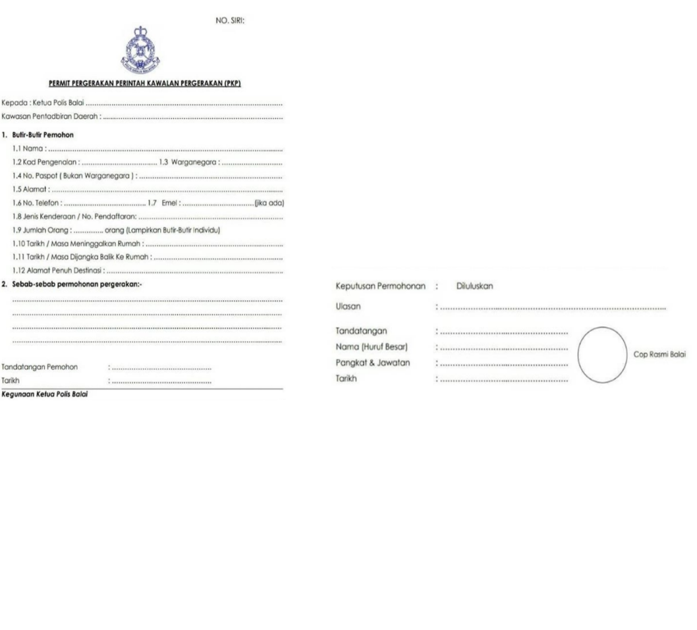

Figure 2.1 Interstate Travel Permit Form

Currently, the process to cross the state are by manually obtaining sign and stamped by police station at the permit form. To get the approval, applicants need to bring the form and supporting documents. This process way is not suitable due to the pandemic situation where we should restrain from staying outdoors for a long time.

Advantages

No devices required

Since only paperwork are used, applicants did not have to bring any smartphone. They will also not encounter any problems if the smartphone is out of battery or did not get any connection.

Disadvantages

Time consuming

The applicants have to queue for a long time at the police station because they need to fill out the form. They will also be stuck in traffic jammed due to roadblock when the officer need to check their permit form as well as the supporting documents.

Inconvenience

Applicants need to bring supporting documents such as IC copy, supporting letter and road tax which makes it troublesome with a lot of paper to bring.

Low security

Roadblock officer can be scammed by people who fake the signature and stamp from a police station because they cannot verify since it is manually.

2.1.2 Bantuan Prihatin Rakyat

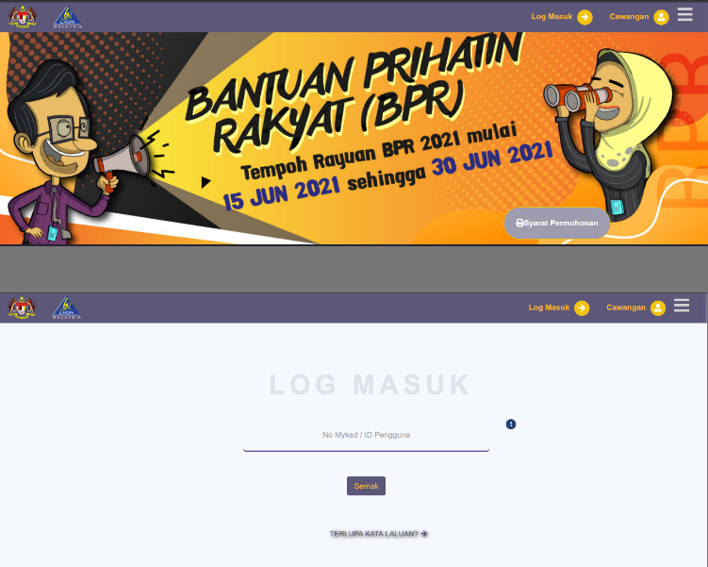

Figure 2.2 Bantuan Prihatin Rakyat

BPR is an application for B40 and M40 group to apply for a financial support that is develop by LHDN. This system replace the old version which is BSH with upgrade of increase in cash allocation. BPR helps household or singles depending on their income and total of kids.

Advantages

View status of approval

User can check their status of approval at the profile page to see if they received the financial help. If the status are denied, BPR system also include the reason of why it got denied.

High security

The system are secured because before logging into the dashboard, the user have to fill in the username and password as well as the security keywords.

User friendly UI

The interface is very simple and easy to use since it is not packed in one page.

Download & Upload features

The system include the download features where user can download the form and profile page. User can upload their supporting documents such as marriage certificate, divorce or death certificate and bank statement during signing up to provide proof.

Disadvantages

Long waiting time

After user has sign up by filling in the form and providing documents if available, they will have to wait until a few month to see their status of approval.

No notification

They did not provide any notification regarding the status because they will only announce the date of each phase.

2.1.2 MySejahtera

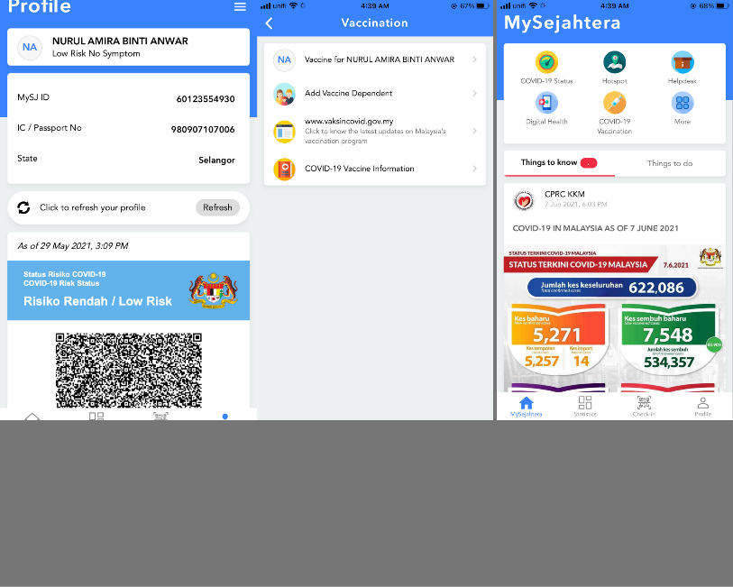

Figure 2.3 MySejahtera

Based on MySejahtera website, the application by the Malaysian government is to facilitate in controlling the COVID-19 pandemic. (MySejahtera, 2021)

All citizens in Malaysia are advised to install the application as it is being use for contact tracing at every entrance location including public transport. The failure of scanning the QR code when entering any premises will resulted to get compound by the police.

Advantages

Tracking system features

MySejahtera can track Covid19 hotspot with the GPS tracking devices that can work when the user allow it to share their current location. Users can view how many positive cases within the radius of 1km.

View statistics

The application provides statistic for the Covid 19 update weekly. The statistics that the user can view is the total confirmed case, total recovered case, total death and active case. Other than that, they also provide statistics with cases by states in Malaysia and global.

Health Risk features

The user health risk can be detected through this application at risk status in the profile page. The status will be check by a guard before the user can scan the QR code to enter the premises. Only user with low risk, casual contact with or without symptom are allowed to scan and enter. If their risk status are confirm case with symptom, suspected case, close contact and person under surveillance, the are prohibited not only to scan but even going out of their quarantine area. The health risk features also provide a QR code.

Scan features

The user must use the application to scan the QR code that are on display at every checkpoint usually at the entrance of any premises. The point for user to scan is so the Health Ministry can trace user’s journey. User can also add dependent after fill in a form about the dependent and can scan for both.

Disadvantages

Lagging

Many complaint about when the application suddenly froze and cannot scan the QR code, this made users mad because they will hold up the line. However, MySejahtera helpdesk provide solution which ask the user to uninstall and install again the application but all the history will vanish.

Complex UI & Features

The application interface is quite compact since it is filled with many features in one page. User also found that the application features are quite hard to understand since it is complicated to know which one to choose. For example, if they wanted to update risk status, they actually need to click at “Covid-19 Status” to answer a few questions and submit it. After that, they need to find the profile page again to see the updated time and date of their risk status.

2.1.2 MMU Mobile

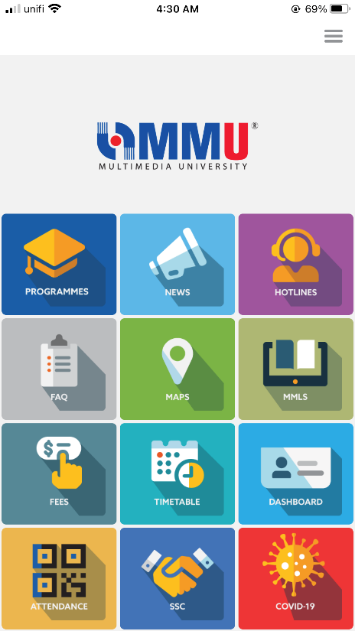

Figure 2.4 MMU Mobile

MMU Mobile are an application that are created to ease the students and staff to check campus related information. The features include dashboard, class schedule, campus info, scan attendance and health pass. The green health pass can be obtained when students fill in the daily health declaration form for 10 days consecutively with good health condition.

Advantages

User friendly UI

The application interface is not messy as it shows the features at the dashboard neatly. The design are also user friendly since it use font and icon that can be seen and understandable.

Scan features

MMU Mobile application provide features where students can scan the QR code provided by the lecturer for class attendance. After the covid 19 cases rise, they update the application by adding the features to scan the venue in MMU.

Receive notifications

Whenever there are news, announcement or documents uploaded, everyone with the application will get a notification. This can help user to keep track of what’s happening in MMU.

Disadvantages

No update or upload features

Since this application is more to information guide, it didn’t allow the user to upload or update anything not even their profile details.

No QR code features

The QR code features is not available for user so it waste a lot of time when the guard have to see the green health pass, approval letter and check temperature.

2.1.2 Gerak Malaysia

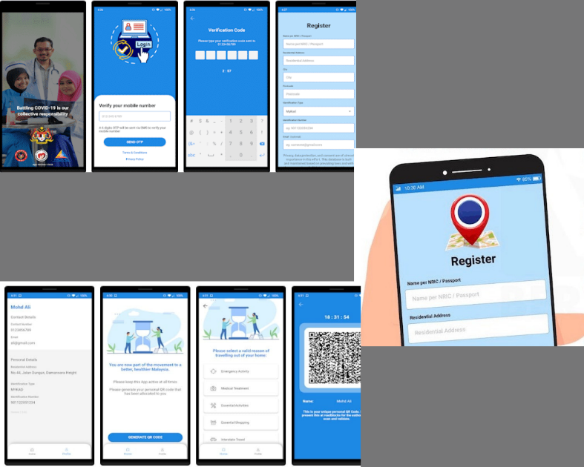

Figure 2.5 Gerak Malaysia

Gerak Malaysia is an application that is develop by MCMC and PDRM to track, manage, trace close case of covid 19 as well as managing the interstate travel permit. The application are mainly for the people who need to return home. This travel permit only allow one way travel and the journey on the highway are divided by states.

Advantages

High security

The application ask for the user TAC number that are sent to their phone number to secure their account.

Tracking features

It can trace the user location by using GPS location and the user need to allow it to cooperate with the police.

Good UI

The interface design are really simple and easy to understand.

QR code available

The availability of the QR code is very good to speed up the process at the roadblock location.

Disadvantages

Incompetence

The disadvantages of this application is that the user need to update the application a lot of time just for them to request the permit and fill in the form. The application also always froze and lagging.

Flow unclear

Even though the UI is very easy to understand, but the flow for this application to work is a bit messed up so it is not suitable for people who is not tech savvy.

No notification

There are no notification for the user to know if they are approved or denied.

2.2 Comparison

Table 2.1 Comparison between existing applications

|  |  |  |  |  |  |  |
| --- | --- | --- | --- | --- | --- | --- |
| Features | Existing Systems | | | | | ITPS |
| Manual | BPR | MySejahtera | MMU Mobile | Gerak Malaysia |
| Pre-request using online form | 🗶 | ✔ | 🗶 | 🗶 | ✔ | ✔ |
| Upload supporting documents | 🗶 | ✔ | 🗶 | 🗶 | ✔ | ✔ |
| View real time logs at dashboard | 🗶 | 🗶 | ✔ | 🗶 | ✔ | ✔ |
| Good User interface | 🗶 | ✔ | 🗶 | ✔ | 🗶 | ✔ |
| Generate statistics report | 🗶 | ✔ | ✔ | 🗶 | ✔ | ✔ |
| Edit profile details | 🗶 | ✔ | ✔ | 🗶 | ✔ | ✔ |
| View status | 🗶 | ✔ | ✔ | 🗶 | ✔ | ✔ |
| Generate QR code | 🗶 | 🗶 | ✔ | 🗶 | ✔ | ✔ |
| Scan QR code | 🗶 | 🗶 | ✔ | ✔ | 🗶 | ✔ |

# Chapter 3 : REQUIREMENTS

3.1 System Overview

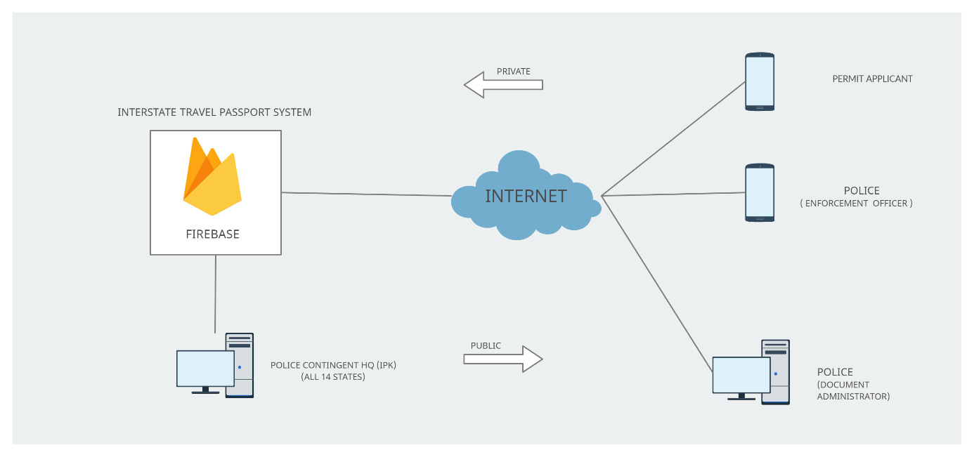

Figure 3.1 System Overview

Figure above display how the Interstate Travel Passport System workflow process. This system work by all of the users get access through Internet and use Firebase the hosting at the server side. The flow will start with the 14 States Police HQ (IPK) that report to Bukit Aman, RMP HQ where they will manage at the server side. As for the database, Firebase are chosen because it has extra features and a fast NoSQL that can be stored at cloud.

This system are mainly for applicants, enforcement officer and document administrator where they have to use a device that support Google Play for the mobile-based application and Windows for the web-based application.

3.2 System Requirements

3.2.1 Software

Android OS version 8.0 or higher is required for permit applicants and enforcement officers who use mobile applications w hile the document administrator who uses a web applications can perform at any Windows operating system.

As for developers, the software required is Android Studio to run and write all of the coding to develop an Android mobile application platform and Firebase for the database.

3.2.2 Hardware

Hardware requirement for using mobile applications is an Android device that supports Android Operating System. It is necessary to use any device that can connect to the internet for web applications, such as WIFI, 3G, 4G, or LTE.

3.3 Functional Requirements

3.3.1 Survey

A survey is conducted through Google Form. Number 1 represent Strongly Disagree, Number 2 is Disagree, Number 3 is Neutral, Number 4 is Agree and lastly for Number 5, it represents Strongly Agree. One of the questions required the user to choose between manual or online and Number 1 represent Manual while Number 2 is online.

3.3.2 Use Case Diagram

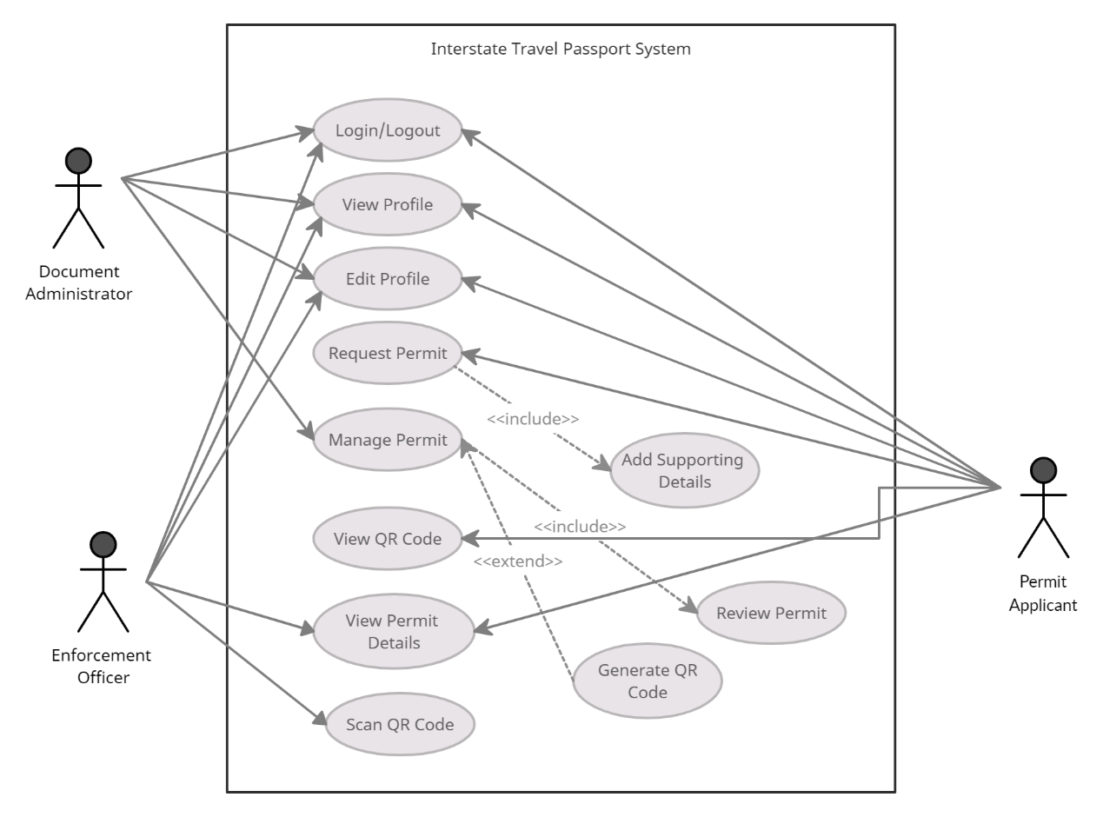

Figure 3.2 Use Case Diagram

3.3.3 Software Requirement Specifications (SRS)

Table 3.1 Use Case 1

|  |  |  |
| --- | --- | --- |
| UC 1 | Login/Logout | |
| Summary | User can sign in with username and password based on their roles. | |
| Success End Condition | User can access the application and directly to dashboard. | |
| Failed End Condition | User cannot access and error message will be shown. | |
| Primary,Secondary Actors | Permit Applicant, Enforcement Officer, Document Administrator (Primary) | |
| Description | Step | Action |
|  | 1 | User can open the ITPS application. |
|  | 2 | At the sign in screen, user have to fill in the username and password and click login. |
|  | 3 | The username and password are obtained when user create an account during sign up. |
|  | 4 | If the username and password is valid, the user will be taken to dashboard screen. |
| Extensions | Step | Branching Action |
|  | 1 | If the username and password is invalid, the user cannot access the application. |
|  | 2 | Error message will be shown : Wrong username/password |

Table 3.2 Use Case 2

|  |  |  |
| --- | --- | --- |
| UC 2 | View Profile | |
| Summary | User can view their profile based on the information during sign up. | |
| Success End Condition | User can check their profile details. | |
| Failed End Condition | No profile details is shown. | |
| Primary,Secondary Actors | Permit Applicant, Enforcement Officer, Document Administrator (Primary) | |
| Description | Step | Action |
|  | 1 | User can click at the Profile button. |
|  | 2 | At the Profile page, user can view their details. |
|  | 3 | The details include Name, IC number, Address, Phone number, Email and profile picture.  For the police side, their Police ID will be included. |
| Extensions | Step | Branching Action |
|  | 1 | If the user did not provide any information during sign up, user cannot proceed to next step. |

Table 3.3 Use Case 3

|  |  |  |
| --- | --- | --- |
| UC 3 | Edit Profile | |
| Summary | User can edit their profile if there are any changes. | |
| Success End Condition | Updated details is recorded. | |
| Failed End Condition | User cannot update. | |
| Primary,Secondary Actors | Permit Applicant, Enforcement Officer, Document Administrator (Primary) | |
| Description | Step | Action |
|  | 1 | User can click at the Profile button and at the Profile page, a smaill icon button to edit the profile is available. |
|  | 2 | The details that can be edited are only Address, Phone number, Email and profile picture. |
|  | 3 | After editing the information, user can click confirm and view the updated details. |
| Extensions | Step | Branching Action |
|  | 1 | If the user did not click Confirm, the details will remain unchanged. |

Table 3.4 Use Case 4

|  |  |  |
| --- | --- | --- |
| UC 4 | Request Permit | |
| Summary | User can apply for a permit via mobile application. | |
| Success End Condition | User’s permit details is recorded. | |
| Failed End Condition | No data is shown. | |
| Primary,Secondary Actors | Permit Applicant (Primary) | |
| Description | Step | Action |
|  | 1 | User can choose the Request button at dashboard. |
|  | 2 | User will be taken to screen where they have to fill in the form. |
|  | 3 | User need to select a police station and insert details such as Name, IC Number, Citizenship, Address, Type of Car, Number plate, Total dependent, Departure and Return date, Destination address and travel reasons. The user also need to include supporting documents such as IC copy, supporting letter and roadtax. |
|  | 4 | If all details and documents are complete, the user status will appear PENDING. |
| Extensions | Step | Branching Action |
|  | 1 | If the user did not include supporting documents, they cannot proceed to click submit and they will not get a status. |
|  | 2 | Error message will be shown : Please attach documents |

Table 3.5 Use Case 5

|  |  |  |
| --- | --- | --- |
| UC 5 | Manage Permit | |
| Summary | User can manage the permit via web application. | |
| Success End Condition | The status for applicant will be changed. | |
| Failed End Condition | No data is shown. | |
| Primary,Secondary Actors | Document Administrator (Primary) | |
| Description | Step | Action |
|  | 1 | User have to click at the List Of Applicants and choose permit applicants with PENDING status. |
|  | 2 | User will view the permit applicant’s details. |
|  | 3 | If the details are complete and the reasons to travel are reasonable, the user will click Approve. |
|  | 4 | The user will be brought to a screen where they will generate a QR code based on the duration stated. After the user click Generate, the status for applicant will change to APPROVED and the permit applicants will receive the QR code. |
| Extensions | Step | Branching Action |
|  | 1 | If the details are incomplete and not acceptable, the user will click Reject and will be brought to a screen where a reasons of rejection should be included. |

|  |  |  |
| --- | --- | --- |
|  | 1 | Error message or no data will be shown. |

Table 3.7 Use Case 6

|  |  |  |
| --- | --- | --- |
| UC 6 | View QR Code | |
| Summary | User will view the QR code at their mobile phone. | |
| Success End Condition | QR code available at Status. | |
| Failed End Condition | No QR code shown. | |
| Primary,Secondary Actors | Permit Applicant (Primary) | |
| Description | Step | Action |
|  | 1 | User can click at Status button. |
|  | 2 | The QR code will be shown along with the APPROVED status so user can show to the enforcement officer at roadblock. |
| Extensions | Step | Branching Action |
|  | 1 | If the user did not go to the police station after requesting, the document administrator cannot proceed with it therefore no QR code will be given. |
|  | 2 | Status will remain PENDING. |

Table 3.8 Use Case 7

|  |  |  |
| --- | --- | --- |
| UC 7 | View Permit Details | |
| Summary | User can view the applicants permit details. | |
| Success End Condition | The permit details of the applicant will be shown. | |
| Failed End Condition | No data is shown. | |
| Primary,Secondary Actors | Enforcement Officer (Primary) | |
| Description | Step | Action |
|  | 1 | After the user scan the QR code from the applicants phone, the permit details will be shown. |
|  | 2 | The permit details include the applicant’s status including the information that filled by them when requesting the permit. |
| Extensions | Step | Branching Action |
|  | 1 | If the applicant’s status is rejected, the user can click the reasons of rejection. |

Table 3.9 Use Case 8

|  |  |  |
| --- | --- | --- |
| UC 8 | Scan QR Code | |
| Summary | User can scan the QR code. | |
| Success End Condition | The applicant’s permit details will appear. | |
| Failed End Condition | Error message will be shown. | |
| Primary,Secondary Actors | Enforcement Officer (Primary) | |
| Description | Step | Action |
|  | 1 | User can click the Scan button. |
|  | 2 | User have to scan the QR code from the applicant’s device. |
|  | 3 | If the QR code is valid, all information will be shown. |
| Extensions | Step | Branching Action |
|  | 1 | If the QR code is invalid, error message will be shown. |

3.3.3 Context Diagram

The diagram shows context diagram where it explains the interaction between users and the system.

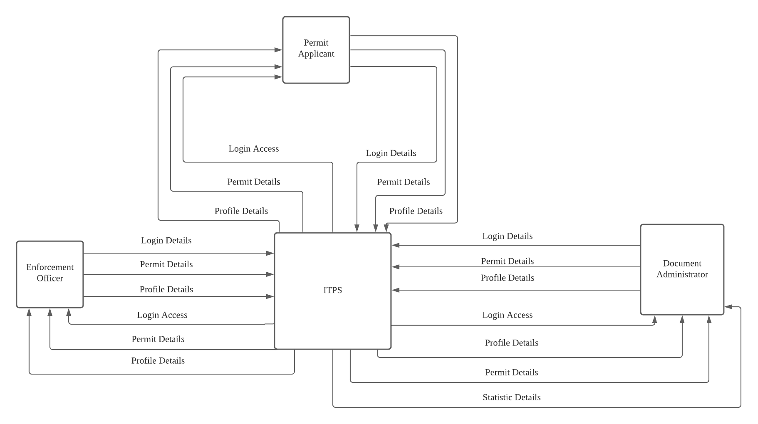

Figure 3.3 Context Diagram

3.3.4 Data Flow Diagram

Data Flow Diagram describes how a device transfers data from input to file storage. Below shows the data flow diagram for permit applicants, enforcement officer and document administrator.

Figure 3.4 DFD Permit Applicants

Figure 3.5 DFD Enforcement Officer

Figure 3.6 DFD Document Administrator

3.3.5 Data Dictionary

# Chapter 4 : DESIGN

4.1 Development Model

There are five models that is always been used to describe the process and one of it is waterfall model. The waterfall model is one of the most extensively utilised classical model of software development. (Nabil & A.Govardhan, 2010). In waterfall model, one stage must be completed before the next one can proceed, hence there can be no overlapping. This model is a sequential design process in which progress is shown to flow smoothly through the five stages which is Requirement Analysis, System Design, Implementation, Testing, Deployment and Maintenance. Interstate Travel Passport System is suited for using this model since a deadline can be set for each stage of development and it can be managed easily because each phase has different deliverables and a review process.( Lakshay Sharma, 2021 )

Figure - Waterfall Model

Requirement Analysis

During this stage, user specifications are obtained, and the analyst test that measure the time and budget constraints determines if the system can meets the requirements.

System Design

The system was designed using various diagrams during this process that includes use case, context diagram, data flow diagram, sequence diagram, system overview and prototype.

Implementation

For implementation stage, user specifications are translated into a system.

Testing

Testing stage employs a variety of testing techniques. Functional Testing, Usability Testing and Load Testing are all part of the test method.

Deployment

Because all processes have been accomplished, the system will be implemented in its professional setting.

Maintenance

During the maintenance process, several issues might appear so the system may require additional improvements and new solutions may be provided.

4.2 Sequence Diagram

Sequence Diagram explains how objects works in order. Below shows diagram for each user which is permit applicants, enforcement officer and document administrator.

4.2.1 Permit Applicants

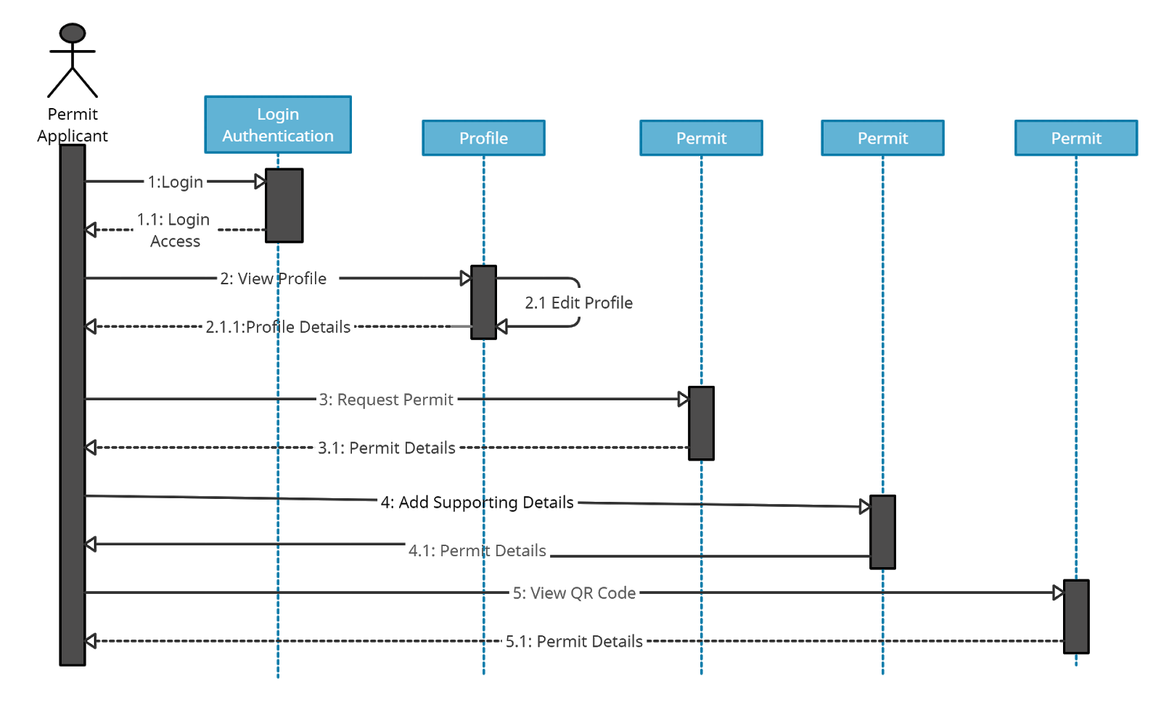

Figure 4.1 Sequence Diagram Permit Applicant

4.2.2 Enforcement Officer

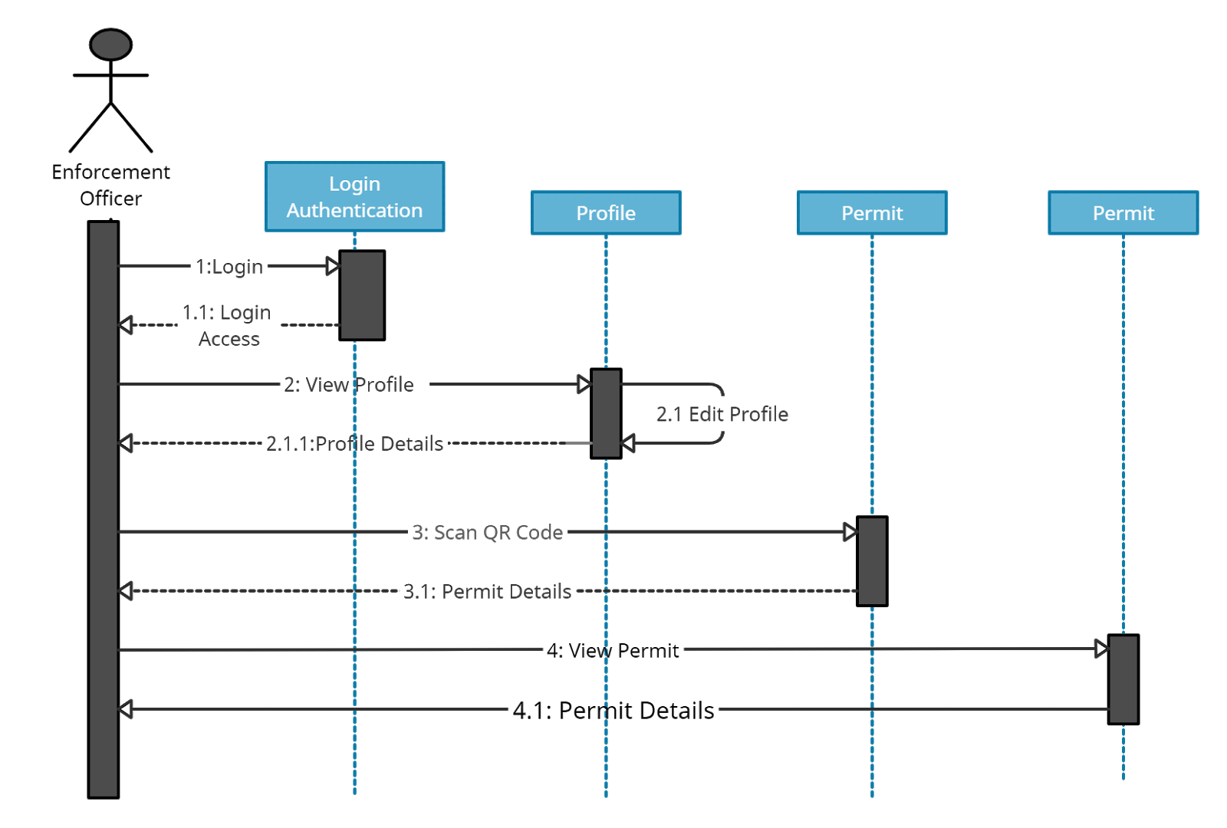

Figure 4.2 Sequence Diagram Enforcement Officer

4.2.3 Document Administrator

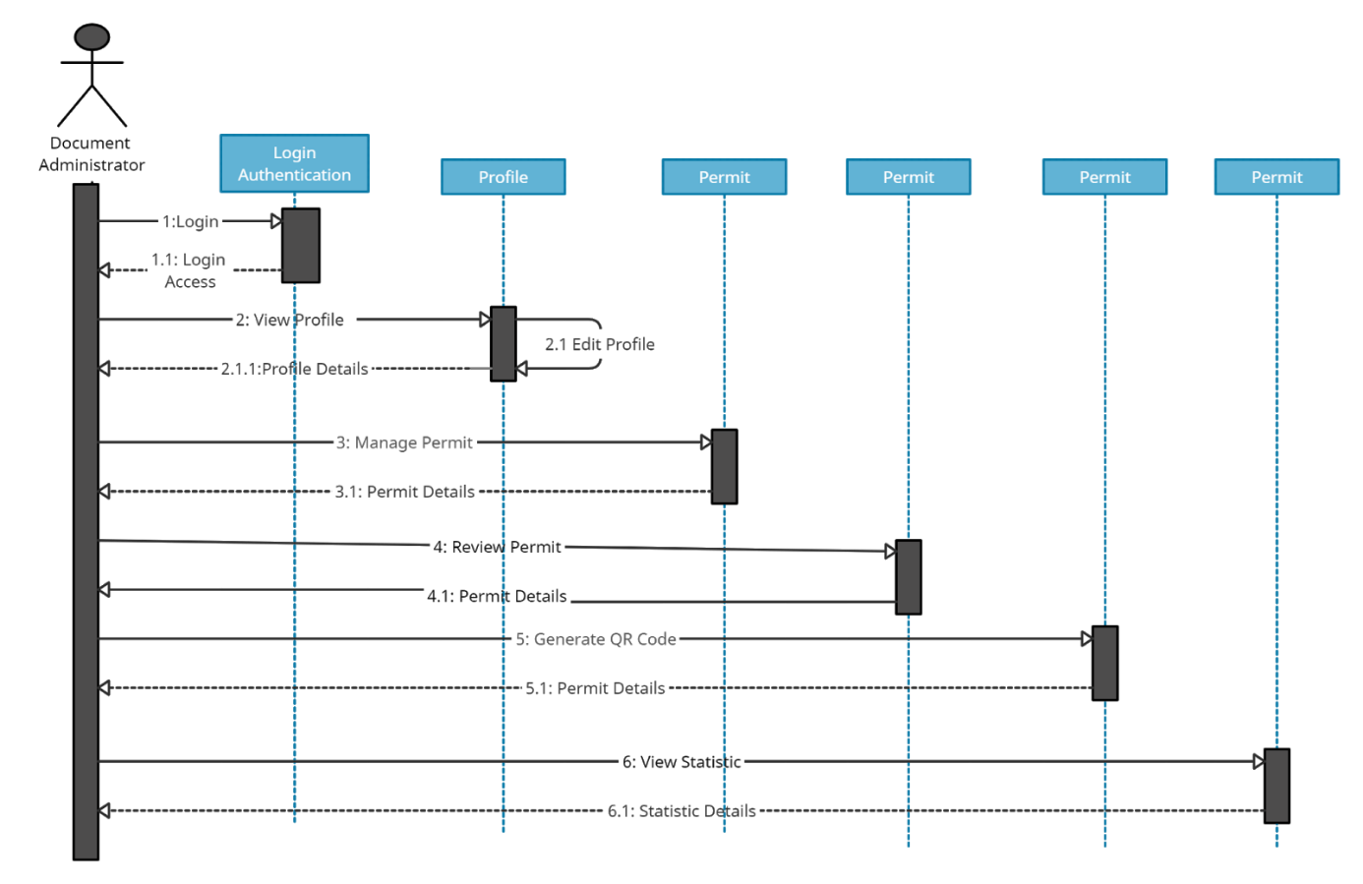

Figure 4.3 Sequence Diagram Document Administrator

# Chapter 5 : Implementation

5.1 Server Implementation

For the web- based applications that is mainly created for Document Administrator, Firebase Hosting is used as the web server.

5.2 User Interface

# Chapter 6 : Testing

GUI Functionality Testing

Usability Testing

This test method requires users to test the system. Observation from the users after they completed the task will be recorded after they give feedback through the google form. User will test the roles as applicant and enforcement officer using mobile applications.

Result and explain guna pie chart

# Chapter 7 : Conclusion

7.1 Conclusion

The normal process of getting approval to cross the state that is currently using manual way is quite inconvenience to most of people especially the applicants and police officers. By developing this system, it helps to smoothen the process when they can save time and reduce paperwork.

The complete project include studying the system that is used which is Workflow Management System. All the requirements and type of workflow management is considered. Information such as what the current technology is needed to develop a system that can be use nowadays.

Next, for a project to be successful, it is necessary to conduct research on existing applications that use a similar system in order to compare and contrast the benefits and drawbacks of using it. After a thorough analyzation, the result collected made the process to develop this system to have a user friendly interface.

Aside from that, after listing the functional requirements and making a preparation to describe how the system will work for the client side, I develop the system for applicant to request the permit, enforcement officer to scan the QR code at the applicant’s device and document administrator to manage the approval of the permit request based on all problem and objectives that I required.

To conclude, the purpose of a system is usually to make the user's life easier. After achieving all the goals and objectives that I have, this system is fully function for the users to use. This system manage to reduce all the problems stated which is using manual form, traffic jams and fraud. The challenges I faced and the knowledge I gained were valuable learning experiences for me, and they will help me prepare for future opportunities.

7.2 Obstacles

The obstacles for me are when I am trying to find existing applications that is similar to my project as references, but there are very limited info. Since I am proposing to develop a new system to update the manual way of Interstate Travel, this is a challenge for me because I need to understand how the process works.

Next, because I am unfamiliar with how to build an application, I am having difficulty deciding what to use to develop the system. However, after careful consideration and research, I have decided to use Android Studio to develop the mobile applications.  Another issue that occurred to me was when I attempted to utilise Flutter at first, it keep crashing and not responding, therefore Dr. Shahida advised me to use another solution.

7.3 Future work

For future work, it would be better to add iOS so the usage of this application can be expanded to users that use smartphone that support iOS. Other than that, another initiative that can help the police force is by applying Automatic Number Plate Recognition (ANPR). We can create robot as another roles in the system and by connecting to ANPR camera, it will detect the plate number. The plate number that is registered during requesting permit will be recognised.

# References

Mysumber. (2020, May 5). Permohonan Gerak Malaysia Online Pergerakan Rentas Negeri. Mysumber.

Farah Solhi.(2020, October 2020). NSC: Police permit required for inter-state travel in or out of CMCO areas. New Straits Times.

Guest Post. (2020, June 5). 10 Features Your Workflow Management System Needs. Retrieved May 2,2021 from https://www.processmaker.com/blog/workflow-management-system/

Nikita Kozin. Malaysia Icon. Retrieved June 5,2021 from <https://thenounproject.com/term/malaysian-flag/221327/>. The Noun Project.

Lakshay Sharma. (2021, October 18). What is Waterfall Model in Software Development Life Cycle | SDLC.

Retrieved November 20, 2021. From <https://www.toolsqa.com/software-testing/waterfall-model/>

Nabil Mohammed Ali Munassar & A.Govardhan (2010). A Comparison Between Five Models Of Software Engineering. *IJCSI International Journal of Computer Science Issues.*